**CERTIFICATE**

This is to certify that the dissertation entitled as “Socio-economic status and mental health among Bheel community of Jaisalmer, Rajasthan” is submitted by Rajdeep Tamuli, a student of MSc. Anthropology (2021-23) of Department of Anthropology, University of Delhi, Delhi- 110007 under my guidance. This work is original and has not been submitted earlier in any form to this University or any other University or Institution.

Signature of Supervisor

Prof. M.P.Sachdeva

Department of Anthropology

University of Delhi

Delhi –110007

**DECLARATION**

I, Rajdeep, do hereby solemnly declare that the dissertation entitled “A Study on Socioeconomic Status and Mental Health among the Bhill community of Jaisalmer, Rajasthan ” has been undertaken by me for the award of Master of Science in Anthropology. I have completed this study under the guidance of Prof. M.P. Sachdeva, University of Delhi.

I also declare that this dissertation has not been submitted for the award of any Degree, Diploma, Associate-ship Fellowship or any other title in this University or any other University.

Name:

Couse:

Roll No:

Date:

**ACKNOWLEDGEMENT**

The victorious completion of a purpose would not be complete without mentioning the people who made it possible. It is my pleasure to express my gratitude and respect to all those who have guided and inspired me throughout my research work.

First of all, I would like to thank Professor M.P. Sachdeva, Head of Department, University of Delhi, New Delhi, for his continuous support, drive, enthusiasm and wealth of knowledge and for providing all the resources needed to complete the dissertation.

It is my great honour to congratulate my advisor, Prof. M.P. Sachdeva, Department of Anthropology, University of Delhi, had the opportunity to work under his supervision. Your prompt guidance, academic freedom and collaboration helped me to complete my research. As a result, the research process became smooth and worthwhile for me.

I am very gratified to Prof. KN Saraswathy who guided me through this process along with my mentor. Their appropriate inspiration, timely guidance, enthusiasm and energy enabled me to complete my research work.

I would like to thank my senior, Apoorva Sharma, a PhD scholar in the Department of Anthropology, University of Delhi, for his great support and constant encouragement during my research project.

I am so grateful for my friends and family. They provided encouragement, constant unconditional support, and gentle reassurance throughout the long and sometimes difficult research process.

Rajdeep

**ABSTRACT**

Understanding the relationship between mental health and socioeconomic status is crucial. This abstract emphasizes how socio-economic factors impact mental health outcomes, mental health's role in shaping socio-economic status, and the importance of addressing disparities for overall well-being and social equity. Comprehensive strategies are needed to integrate mental health support and reduce socioeconomic inequalities. Quantitative methods involve collecting and analysing numerical data to study phenomena, relying on statistical analysis for objective conclusions. There is no significant relationship between depression and stress with socio-economic status, but there is a significant relationship with anxiety. The relationship between mental health and socio-economic status has implications for health equity, access to resources, social mobility, and overall quality of life.

**Keywords:** Socio-economic Status, Mental health, Depression, Anxiety, Stress.

Table of Contents

INTRODUCTION: 7

Prevalence of Mental Health Issues: 8

Patient Health Questionnaire-9 (PHQ-9) 8

Perceived Stress Scale-10 (PSS-10) 9

Generalized Anxiety Disorder-7 10

Impact of Socioeconomic Status on Mental Health Outcomes: 10

The rationale of the study: 12

AIM: 13

OBJECTIVES: 13

LITERATURE REVIEW 14

Introduction: 15

Literature Review 15

The association between mental health and socioeconomic status 15

The association between mental health and socio-economic status using PHQ9. 18

The association between mental health and socio-economic status using PSS10. 18

The association between mental health and socio-economic status using GAD7. 18

Uday Parekh scale 18

AREA AND PEOPLE: 20

Geography and Climate: 21

Historical and Cultural Significance: 23

Demographics: 23

Economy: 24

EDUCATION: 26

Infrastructure and Development: 27

ADMINISTRATION 28

SOCIAL DYNAMICS: 30

Challenges and Opportunities: 30

METHODOLOGY: 33

AN OVERVIEW OF THE RESEARCH APPROACH 33

THE RESEARCH DESIGN, PHILOSOPHY, APPROACH, AND STRATEGY: 33

DATA COLLECTION METHODS 33

THE DATA ANALYSIS METHODS 34

THE VALIDITY AND RELIABILITY 34

SUMMARIZING THE KEY POINTS OF METHODOLOGY AND CONTRIBUTION: 35

RESULT 38

Table 1: Demographic data 38

Table2: Distribution Of Socioeconomic Status 42

Table: 3 Chi-Square test 44

Depression With Socio-economic Status 44

Stress with Socio-economic Status 47

Anxiety with Socio-economic Status 49

Regression Analyses 50

Discussion: 53

CONCLUSION & LIMITATIONS 56

Conclusion 56

Limitations of the research 56

Future Research 57

EXPERIENCE 60

Reference: 65

**CHAPTER 1**

**INTRODUCTION**

# INTRODUCTION:

As documented by the World Health Organization, depression remains one of the principal causes contributing towards disability worldwide with projections indicating it may surpass other conditions as the most significant contributor towards global disease burden by 2030. This dissertation focuses on understanding how various elements linking socioeconomic status such as occupational categories, levels of education achieved or earned income contribute towards shaping an individual's mental state through exploring their impacts on mental well-being within different social contexts emphasizing the complex nature of this relationship.

The alarming rise in cases of individuals experiencing different mental illnesses continues to be a troubling issue across all continents globally. Recently there has been an observable trend where these instances have only become more prevalent over time than they were before. This situation was inadvertently worsened by the advent of COVID-19 in 2020 which brought about several long-lasting socio-economic effects worldwide. As such it is now widely accepted that we may be facing an impending worldwide public health crisis concerning people's psychological welfare because of these events' impact on society at large. Researchers have found that socioeconomic status can significantly influence one's chances of experiencing adverse outcomes concerning their mental functioning.

## Prevalence of Mental Health Issues:

According to India’s National Mental Health Survey conducted for two consecutive years (2015 16) on adults between the ages of eighteen and sixty-five, about fourteen per cent (14%) frequently experience some form of mental impairment each year. The prevalence rate exposes Depression as the leading type globally with Major Depressive Episodes reporting an annual incidence rate of about 4.5% among adults living in India - women count dominant frequencies against men. Anxiety disorders rank second amongst commonly occurring mental health issues. Generalized Anxiety Disorder (GAD) and panic disorder are the most prevalent categories; affecting an estimated 4.4% of India's adult population each year. On a downside note, underreporting incidents contribute significantly to lower-than-expected statistics coupled with inadequate access to healthcare facilities or medical resources required for tackling psychological conditions among Indians necessitating further probing on actual prevalence rates exceeding current statistical estimates.

## Patient Health Questionnaire-9 (PHQ-9)

The Patient Health Questionnaire-9 (PHQ-9) is a tool used to screen for and diagnose depression. The PHQ-9 consists of nine questions that ask about symptoms of depression, such as low mood, loss of interest in activities, and feelings of worthlessness or guilt. Each question is scored from 0 to 3, with 0 indicating that the symptom is not present and 3 indicating that the symptom is present nearly every day. The scores for each question are added up to give a total score, which can range from 0 to 27. More severe depression is indicated by a higher score. The PHQ-9 is a widely used and validated tool that can be used in a variety of settings, such as primary care, mental health clinics, and research studies. It is a useful tool for screening for depression, as it is quick and easy to administer, and it can help identify patients who may benefit from further evaluation and treatment. The PHQ-9 can also be used to monitor the severity of depression over time and to evaluate the effectiveness of treatment. By administering the PHQ-9 at regular intervals, clinicians can track changes in depression symptoms and adjust treatment as needed. One potential limitation of the PHQ-9 is that it relies on self-reported symptoms, which may be subject to bias or inaccuracies. Additionally, the PHQ-9 is not a diagnostic tool and should not be used as the sole basis for diagnosing depression. A comprehensive evaluation that includes a clinical interview and other diagnostic tools may be necessary to confirm a diagnosis of depression.

## Perceived Stress Scale-10 (PSS-10)

The Perceived Stress Scale-10 (PSS-10) is a widely used tool for measuring an individual's perceived stress levels. The PSS-10 consists of 10 questions that assess how often a person has experienced stress in the past month, such as feeling nervous, stressed, or overwhelmed. Each question is scored on a 5-point scale, with 0 indicating that the question is never true and 4 indicating that the question is always true. The scores for each question are added up to give a total score, which can range from 0 to 40. An increased score denotes more felt stress.

The PSS-10 is a useful tool for assessing stress levels in a variety of settings, such as research studies, clinical practice, and occupational health. It is a quick and easy tool to administer, and it can help identify individuals who may be at risk for stress-related health problems. The PSS-10 can also be used to monitor stress levels over time and to evaluate the effectiveness of stress-reduction interventions. By administering the PSS-10 at regular intervals, clinicians and researchers can track changes in stress levels and determine whether interventions are having a positive impact. One potential limitation of the PSS-10 is that it is a self-reported measure of perceived stress, and individuals may differ in their interpretation of what constitutes stress. Additionally, the PSS-10 does not assess the source or type of stress, which may be important for understanding the impact of stress on health outcomes.

## Generalized Anxiety Disorder-7

The Generalized Anxiety Disorder-7 (GAD-7) is a tool used to screen for and diagnose a generalized anxiety disorder. The GAD-7 consists of seven questions that ask about symptoms of anxiety, such as feeling nervous, worrying excessively, and having trouble relaxing. Each question is scored from 0 to 3, with 0 indicating that the symptom is not present and 3 indicating that the symptom is present nearly every day. The scores for each question are added up to give a total score, which can range from 0 to 21.

The GAD-7 is a widely used and validated tool that can be used in a variety of settings, such as primary care, mental health clinics, and research studies. It is a useful tool for screening for anxiety, as it is quick and easy to administer, and it can help identify patients who may benefit from further evaluation and treatment. The GAD-7 can also be used to monitor the severity of anxiety over time and to evaluate the effectiveness of treatment. By administering the GAD-7 at regular intervals, clinicians can track changes in anxiety symptoms and adjust treatment as needed. One potential limitation of the GAD-7 is that it relies on self-reported symptoms, which may be subject to bias or inaccuracies. Additionally, the GAD-7 is not a diagnostic tool and should not be used as the sole basis for diagnosing generalized anxiety disorder. A comprehensive evaluation that includes a clinical interview and other diagnostic tools may be necessary to confirm a diagnosis of generalized anxiety disorder.

## Impact of Socioeconomic Status on Mental Health Outcomes:

Socioeconomic status refers to an individual's position within society concerning both their economic resources and social standing - including factors such as income, education level, and occupational prestige. As numerous studies have found over time there is a significant link between one's socioeconomic background and their mental wellbeing. People from lower socioeconomic backgrounds tend to be more vulnerable when it comes to experiencing negative mental health outcomes compared with those from higher socioeconomic classes. One reason for this disparity is that individuals from lower socioeconomic backgrounds are more likely to experience chronic stress due to financial instability, job insecurity, and exposure to violence and discrimination. Chronic stress can lead to the development of mental health issues similar to anxiety and depression.( NPG.R., 2023) In addition, those hailing from lower socioeconomic strata might confront difficulties availing themselves of appropriate mental health services which could exacerbate their existing psychological issues. According to research conducted by the Substance Abuse and Mental Health Services Administration (SAMHSA), the likelihood of people residing in low-income households receiving proper treatment for their mental health disorders is significantly less than that of people from higher income brackets. This inequity concerning healthcare provision may contribute towards untreated psychiatric conditions resulting in unwanted ramifications on individuals' emotional welfare.

There is a significant lack of research on the relationship between mental health and socio-economic status, particularly in developing countries like India. This is a crucial area of study because socio-economic factors such as income, education, and occupation have been found to be associated with mental health outcomes, including depression, anxiety, and stress. In the context of **Jaisalmer, Rajasthan**, there is a need for further research on this topic as the region is marked by a high level of poverty and limited access to mental health services. Despite the potential impact of socio-economic factors on mental health, little is known about the specific mechanisms through which these factors influence mental health in this region. Additionally, there is a need to understand the unique cultural and social factors that may influence mental health outcomes in Jaisalmer.

Therefore, my dissertation will focus on exploring the relationship between socioeconomic status and mental health outcomes in Jaisalmer, Rajasthan. The study will use a mixed-methods approach to collect data from both quantitative surveys and qualitative interviews with individuals from different socio-economic backgrounds. This study is essential as it will help shed light on the factors that influence mental health in Jaisalmer, and inform the development of effective interventions and policies to address mental health disparities in the region.

There is a significant relationship between mental health and socio-economic status, as measured by the Uday Parekh scale, but the relationship may not be straightforward.

The PHQ9, PSS10, and GAD6 are all commonly used measures of mental health, and they assess different aspects of mental health, such as depression, anxiety, and stress. The Uday Parekh scale is a measure of socio-economic status that takes into account factors such as income, education, occupation, and housing.

Research suggests that individuals with lower socio-economic status are at a greater risk of experiencing poor mental health outcomes, such as depression, anxiety, and stress. This may be due to a range of factors, including financial stress, lack of access to healthcare, social isolation, and discrimination.

However, the relationship between mental health and socio-economic status may not be straightforward. For example, some studies have found that individuals from higher socio-economic backgrounds may experience higher levels of stress due to work-related factors, such as long hours or high-pressure environments.

Overall, while there is a relationship between mental health and socio-economic status, the exact nature of this relationship may vary depending on a range of individual and contextual factors.

Studying the relationship between mental health and socioeconomic status is significant as it helps to identify disparities in mental health outcomes among different socioeconomic groups. It can help to identify risk factors for poor mental health outcomes, develop effective interventions, improve mental health policy, and contribute to overall societal well-being. Understanding this relationship is crucial in addressing the mental health needs of individuals and communities from different socioeconomic backgrounds, reducing the burden of mental illness, promoting social cohesion, and improving productivity and economic outcomes.

## The rationale of the study:

The rationale for studying the relationship between mental health and socioeconomic status is to better understand how socioeconomic factors impact mental health outcomes. There is evidence to suggest that individuals from lower socioeconomic backgrounds are at higher risk for poor mental health outcomes, including depression, anxiety, and substance use disorders. Financial stress, social isolation, discrimination, and other factors associated with lower socioeconomic status may contribute to the development of mental health problems.

Studying the relationship between mental health and socioeconomic status can help identify disparities in mental health outcomes among different socioeconomic groups, inform the development of prevention and early intervention strategies, and improve access to mental health services for disadvantaged individuals and communities. Understanding this relationship can also inform the development of effective policies and programs to address the mental health needs of all individuals and promote overall societal well-being.

Overall, the rationale for studying the relationship between mental health and socioeconomic status is to improve our understanding of how socioeconomic factors impact mental health outcomes and inform the development of interventions to promote better mental health outcomes for all individuals, regardless of their socioeconomic status.

AIM: To understand the relationship between socio-economic status and mental health.

# OBJECTIVES:

1. To analyse the distribution of socio-economic status.
2. to examine the relationship between socioeconomic status (SES) and three mental health factors: depression, anxiety, and stress.

**CHAPTER 2**

**LITERATURE REVIEW**

# LITERATURE REVIEW

## Introduction:

Mental health and socio-economic status (SES) are two important areas of research in public health. Mental health problems are prevalent worldwide, and SES is a factor that has been found to be associated with mental health outcomes. Understanding the relationship between mental health and SES is crucial for developing effective interventions aimed at improving mental health outcomes for individuals from lower SES backgrounds. This dissertation aims to explore the relationship between mental health and SES and to identify the factors that contribute to this relationship.

## Literature Review

### The association between mental health and socioeconomic status

Numerous studies have shown a significant association between low SES and poor mental health outcomes. Individuals with low SES are more likely to experience psychological distress, depression, anxiety, and other mental health problems than those with high SES. A study conducted by Lorant et al. (2017) found that people with low SES were more likely to experience mental distress than those with high SES. Another study by Marmot (2015) showed that individuals with low SES were more likely to experience depression and anxiety. Research has shown that the relationship between SES and mental health is complex and multifaceted. Several factors contribute to the link between SES and mental health, such as access to healthcare, social support, and exposure to stressors. A study by Muntaner et al. (2018) suggested that the social determinants of health, including SES, are crucial in shaping mental health outcomes. Individuals with low SES may face greater exposure to stressors, including financial stress, housing insecurity, and discrimination, which can increase the risk of mental health problems. Moreover, low SES is associated with limited access to healthcare, which can also affect mental health outcomes. People with low SES may have limited access to mental health services, making it difficult to address mental health issues. A study by Mackenzie et al. (2019) found that individuals with low SES were less likely to receive mental health services than those with high SES.

On the other hand, some studies have suggested that the relationship between SES and mental health may not be straightforward. For example, a study by Roos et al. (2014) found that while low SES was associated with a higher risk of mental health problems, high SES was also associated with a higher risk of certain mental health issues, such as alcohol abuse. A review of the literature by Lund et al. (2010) found that individuals with lower socio-economic status were at a higher risk of experiencing mental health problems such as depression and anxiety. Similarly, a meta-analysis conducted by Mair et al. (2010) found that lower socio-economic status was associated with an increased risk of mental health problems, particularly depression. The experience of poverty is a key factor that contributes to the relationship between socioeconomic status and mental health. Individuals living in poverty often experience stress, uncertainty, and a lack of control, which can all contribute to poor mental health outcomes (Krieger, 2017). Additionally, poverty can lead to social isolation and exclusion, which can exacerbate mental health problems. While the impact of socioeconomic status on mental health has been extensively studied, the reverse relationship has also received attention in the literature. Mental health problems can have a significant impact on an individual's socioeconomic status. For example, individuals with mental health problems may find it difficult to maintain employment or access education, which can have long-term impacts on their socioeconomic status (Eaton et al., 2012). Furthermore, some researchers have suggested that the relationship between SES and mental health may vary across different cultures and contexts. A study by Assari et al. (2018) showed that the association between SES and mental health varied by race/ethnicity. For example, the study found that low SES was associated with higher levels of depression among African Americans but not among Whites. There are several interventions that have been proposed to mitigate the negative impact of socioeconomic status on mental health outcomes. One such intervention is increasing access to healthcare and social support services. For example, a study by Norris et al. (2017) found that increasing access to mental health services in low-income areas led to significant improvements in mental health outcomes.

Providing education and employment opportunities is another intervention that can help to improve socio-economic status and reduce the risk of mental health problems. A review by Lund et al. (2010) found that providing education and employment opportunities led to significant improvements in mental health outcomes, particularly for individuals with low socio-economic status.

Furthermore, mental health problems can lead to increased healthcare costs and decreased productivity, which can further contribute to lower socioeconomic status (Eaton et al., 2012). A review by Knapp et al. (2011) found that mental health problems cost the UK economy billions of pounds annually due to lost productivity, healthcare costs, and other related expenses.

Limited access to healthcare is another factor that contributes to the relationship between socioeconomic status and mental health. Individuals with lower socio-economic status often have less access to healthcare, which can make it difficult to access treatment for mental health problems. This can lead to untreated mental health issues, which can have serious long-term consequences (Lund et al., 2010).

Several studies have found a strong association between socioeconomic status and mental health. One such study conducted in India found that people from lower socio-economic backgrounds had higher levels of stress, as measured by the Uday Pareek Scale than those from higher socio-economic backgrounds (Sinha, 2013).

Similarly, another study conducted in the United States found that individuals with lower incomes and education levels had higher levels of perceived stress, as measured by the PSS-10 than those with higher incomes and education levels (Cohen et al., 2016). The study also found that individuals who perceived themselves as having a lower social status had higher levels of stress. This suggests that perceived social status may play a role in the relationship between socioeconomic status and mental health.

Furthermore, several studies have explored the relationship between socioeconomic status and anxiety levels. One such study conducted in South Africa found that individuals from lower socio-economic backgrounds had higher levels of anxiety, as measured by the GAD-7 than those from higher socio-economic backgrounds (Charlson et al., 2016). Another study conducted in Australia found that individuals with lower socio-economic status had higher levels of anxiety and depression, as measured by the GAD-7 and PHQ-9, respectively (Hudson et al., 2015).

These studies collectively suggest that there is a strong relationship between socioeconomic status and mental health, as measured by various scales. Individuals from lower socio-economic backgrounds tend to have higher levels of stress, depression, and anxiety, and this may be due to a range of factors, including financial insecurity, limited access to healthcare, and social exclusion. It is important for policymakers to address these issues and implement interventions that can help alleviate the negative effects of socioeconomic disadvantage on mental health.

## The association between mental health and socio-economic status using PHQ9.

Several studies have examined the relationship between mental health and SES using the PHQ-9, which is a widely used tool for assessing depression symptoms. For instance, a study by Lund et al. (2016) found that individuals with lower SES had higher rates of depression symptoms. The study used the PHQ-9 to measure depression symptoms and found that those with lower income and education levels had higher PHQ-9 scores. Similarly, a study by Schickedanz et al. (2017) found that low SES was associated with increased depressive symptoms in a large sample of older adults. Study conducted in the United States found that individuals with lower incomes and education levels had higher levels of depression, as measured by the PHQ-9, than those with higher incomes and education levels (Boden-Albala et al., 2005).

## The association between mental health and socio-economic status using PSS10.

Studies have also used the PSS-10 to examine the relationship between SES and perceived stress. Perceived stress refers to the subjective experience of stress and is an important predictor of mental health outcomes. For instance, a study by Goodman et al. (2014) found that individuals with lower SES had higher levels of perceived stress. The study used the PSS-10 to measure perceived stress and found that those with lower income and education levels had higher PSS-10 scores.

## The association between mental health and socio-economic status using GAD7.

The GAD-7 is another tool commonly used to measure anxiety symptoms. Several studies have examined the relationship between SES and anxiety symptoms using the GAD-6. For example, an examination by Hicken et al. (2018) found that racial discrimination was associated with higher levels of anxiety symptoms, as measured by the GAD-6. The study used the GAD-6 to measure anxiety symptoms and found that experiences of racial discrimination were associated with higher GAD-6 scores. Another study by Butterworth et al. (2013) found that lower SES was associated with higher rates of anxiety disorders in a large population-based sample of adults in Australia.

## Uday Parekh scale

The Uday Parekh scale is a tool that has been used to measure SES in various studies. This scale includes a range of indicators such as income, education, and occupation, and provides a comprehensive measure of SES. Several studies have used the Uday Parekh scale to examine the relationship between SES and mental health outcomes. For instance, a study by Singh et al. (2019) found that lower SES was associated with higher rates of depression symptoms, as measured by the PHQ-9, and perceived stress, as measured by the PSS-10. The study used the Uday Parekh scale to measure SES and found that those with lower SES had higher PHQ-9 and PSS-10 scores.

**CHAPTER 3**

**AREA AND PEOPLE**

# AREA AND PEOPLE:

The area for the present study is based in Rajasthan, Jaisalmer. Jaisalmer is a city located in the western Indian state of Rajasthan. It is known for its magnificent sandstone fort, Jain temples, and Havelis (old mansions). The city is also famous for its camel safaris and its proximity to the Thar Desert. The area of Jaisalmer city is approximately 5.1 square kilometres (1.97 square miles), while the total area of Jaisalmer district is 38,401 square kilometres (14,836 square miles), which includes the city as well as rural areas.

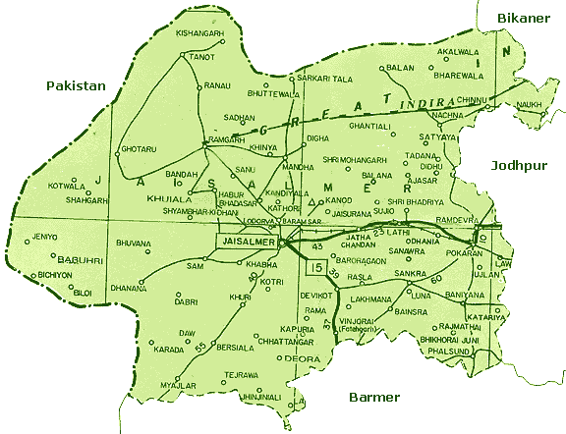

## Geography and Climate:

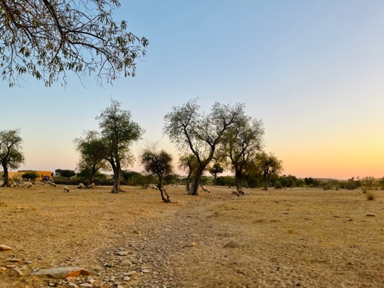Jaisalmer is a city located in the western Indian state of Rajasthan. The region is part of the Thar Desert and is characterized by its arid climate, hot temperatures, and scarce vegetation. The topography of Jaisalmer is mainly flat and characterized by sand dunes and rocky outcrops. The Thar Desert, also known as the Great Indian Desert, is one of the world's largest deserts and covers most of the region. The terrain is generally rocky and sandy, with occasional hills and small mountains in the vicinity. The region has a few rivers, such as the Luni, but they are mostly seasonal and dry up during the hot summer months.

The clima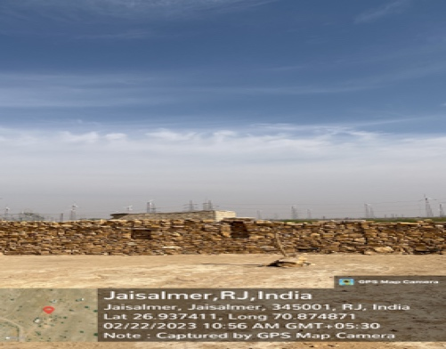te in Jaisalmer is classified as a hot desert climate with very little rainfall throughout the year. Summers are extremely hot, with temperatures exceeding 40°C (104°F) during the day, while winters are mild, with daytime temperatures averaging around 23°C (73°F). The region experiences frequent sandstorms during the summer months, which can be very intense and last for several days.

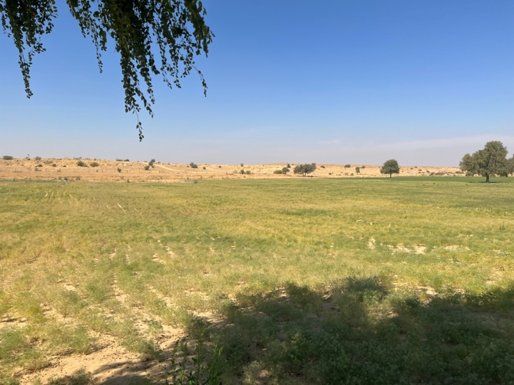Vegetation in Jaisalmer is scarce, with most of the land covered by sand dunes and rocky terrain. The desert supports sparse vegetation, such as thorny bushes, scrub, and cacti, which can survive in the arid climate. However, the region has some oases and wetlands that support more extensive vegetation, such as date palms and acacia trees, which provide shade and food for wildlife.

The arid climate and sparse vegetation of Jaisalmer have influenced the region's economy and society. The region's main economic activities include agriculture, tourism, and handicrafts. Agriculture is limited to areas around the oases and relies on irrigation systems to grow crops such as wheat, barley, and vegetables. Tourism is a growing industry in Jaisalmer, with visitors attracted to the city's stunning architecture and cultural heritage. Handicrafts, particularly textiles, jewelry, and leather goods, are also important to the region's economy.

In conclusion, Jaisalmer is a region characterized by its arid climate, hot temperatures, and sparse vegetation. Its flat topography is dominated by sand dunes and rocky outcrops. The region's economy and society are shaped by the scarcity of water and vegetation, which has led to a reliance on agriculture, tourism, and handicrafts.

## Historical and Cultural Significance:

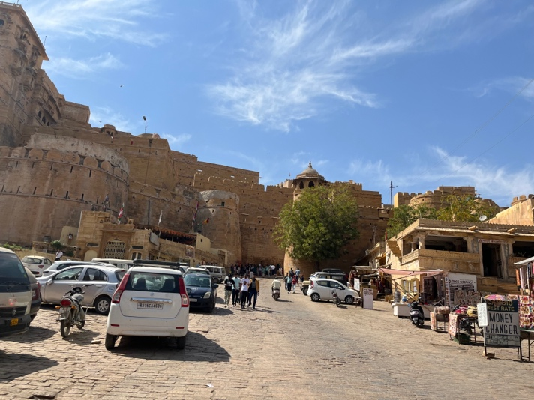The Jaisalmer Fort, also known as Sonar Qila, is one of the most iconic milestones in the city. The fort was erected in 1156 AD and is made entirely of unheroic sandstone, giving it a golden tinge. The stronghold is home to several ornate Jain tabernacles, palaces, and Havelis, including the Patwon Ki Haveli, Nathmal Ki Haveli, and Salim Singh Ki Haveli. Another important literal point in Jaisalmer is the Gadsisar Lake, which was erected in the 14th century to serve as a force for the city. The lake is girdled by several tabernacles, sanctuaries, and chhatris( landmarks) and is a popular spot for voyaging and picnicking. Jaisalmer is also known for its vibrant carnivals, music, and art. The Desert Festival, held every time in February, is a three-day event that showcases the rich culture and traditions of the region. The jubilee features camel races, folk music and cotillion performances, and traditional Rajasthani cookery. The music of Jaisalmer is characterized by the use of traditional instruments similar as the dholak, sarangi, and khartal. The region is also known for its intricate crafts, including fabrics, crockery, and leatherwork. The cookery of Jaisalmer is an emulsion of Rajasthani and Mughlai cookeries and is known for its rich and racy flavors. Some popular dishes include dal baati churma, ker sangri, and gatte ki sabzi. Overall, Jaisalmer is a unique and culturally rich city that offers callers regard into the rich history and traditions of Rajasthan.

## Demographics:

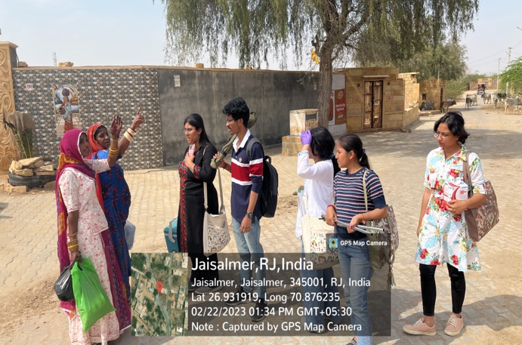Jaisalmer has a diverse demographic profile with a mix of different religions and castes. According to the 2011 Census of India, the population of Jaisalmer was 65,471, with a male-to-female ratio of 926 females per 1000 males. The median age of the population was 28.3 years, which is relatively young compared to the national average.

The majority of the population in Jaisalmer is Hindu, with a significant Muslim population as well. Other religious communities in the city include Jains, Sikhs, and Christians.

In terms of **caste,** Jaisalmer has a mix of different castes, including Rajputs, Jats, Brahmins, and other backward castes. The Rajputs, who are traditionally a warrior caste, are particularly prominent in Jaisalmer and have played an important role in the history and culture of the region.

Over the years, there have been some **changes in the demographic profile** of Jaisalmer. One significant change has been the influx of tourists to the city, particularly since the 1990s. This has led to an increase in the number of people involved in the hospitality industry and related services.

Another **significant change** has been the development of renewable energy projects in the region, particularly wind and solar energy. This has led to an increase in the number of people working in the renewable energy sector and related industries.

Overall, Jaisalmer is a diverse and dynamic city with **a unique demographic profile** that has been shaped by its history, culture, and economic development.

## Economy:

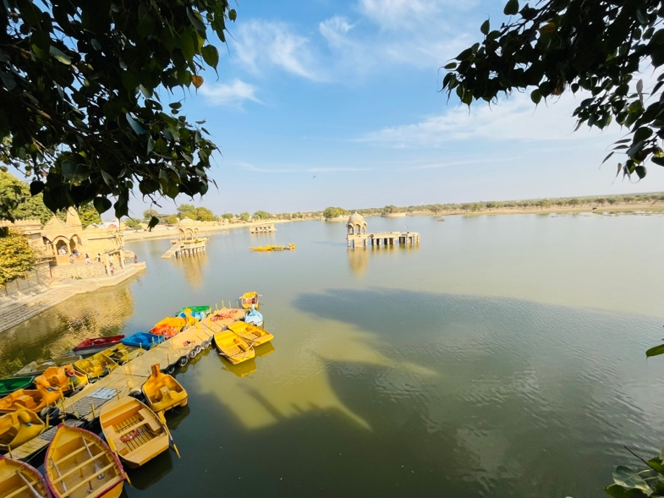Tourism forms one of the most critical pillars holding up the economy of Jaisalmer along with two other key sectors; agriculture and handicrafts. Thanks to the city's location just next door to the Thar Desert plus timeless attractions like Jaisalmer Fort or Jain temples - a significant stream of visitors comes pouring in each year. Alongside tourism is an equally important agricultural sector where crop profits centre around staples including wheat, bajra, and mustard which together keep this local economy thriving.

Mool Sagar, Amar Sagar, Damodara Village, and Kanoi Village are small settlements located in the Jaisalmer district, and their economies are largely dependent on agriculture and handicrafts. Many residents in these villages are engaged in small-scale farming, and some are involved in the production of traditional handicrafts such as textiles and pottery.

One unique feature of the economy in Jaisalmer is the presence of sandstone mining, which is a major industry in the region. The sandstone extracted from the region is used in the construction of buildings and monuments both within India and abroad.

In terms of employment opportunities, the tourism industry is a major source of jobs in Jaisalmer, with many locals working in hotels, restaurants, and as tour guides. Agriculture and handicrafts also provide employment opportunities for local residents.

However, the local economy in Jaisalmer faces several challenges. One of the biggest challenges is the water scarcity in the region, which makes agriculture difficult and limits economic opportunities. In addition, the lack of industrial development in the region means that job opportunities are limited, and many young people are forced to migrate to other cities in search of work.

## EDUCATION:

Education in Jaisalmer, Rajasthan, has seen significant improvement over the years, but the region still faces several challenges. The literacy rate in Jaisalmer has increased from 39.7% in 2001 to 57.94% in 2011, according to the Census of India. However, this is still lower than the national literacy rate of 74.04%.

One of the primary challenges in Jaisalmer is the lack of educational infrastructure, particularly in rural areas. Many villages have only one primary school, which makes it difficult for children to access education beyond the elementary level. The shortage of qualified teachers is another issue that affects the quality of education in the region. In many schools, there is a lack of facilities like laboratories, libraries, and playgrounds, which hampers the overall learning experience.

Despite these challenges, efforts have been made to improve the education system in Jaisalmer. The government has implemented several programs, including the Sarva Shiksha Abhiyan, to increase enrollment and retention rates, especially for girls. The Mid-Day Meal Scheme has also been introduced to provide nutritious meals to children and encourage them to attend school regularly.

Higher education options in Jaisalmer are limited, with only a few colleges and universities in the region. The Jaisalmer Engineering College, Government College Jaisalmer, and Maharaja Ganga Singh University are some of the prominent educational institutions in the region.

Another notable initiative in Jaisalmer is the establishment of the Jaisalmer Vikas Kendra, a non-governmental organization that focuses on providing education and skill development opportunities to underprivileged children in the region. The organization runs several programs, including a residential school for girls, which provides education and vocational training to girls from poor families.

In conclusion, while the education system in Jaisalmer faces several challenges, efforts have been made to improve the quality and accessibility of education in the region. The government has implemented programs to increase enrollment and retention rates, while non-governmental organizations like the Jaisalmer Vikas Kendra are working to provide education and skill development opportunities to underprivileged children. However, more needs to be done to address the shortage of educational infrastructure and qualified teachers in rural areas.

## Infrastructure and Development:

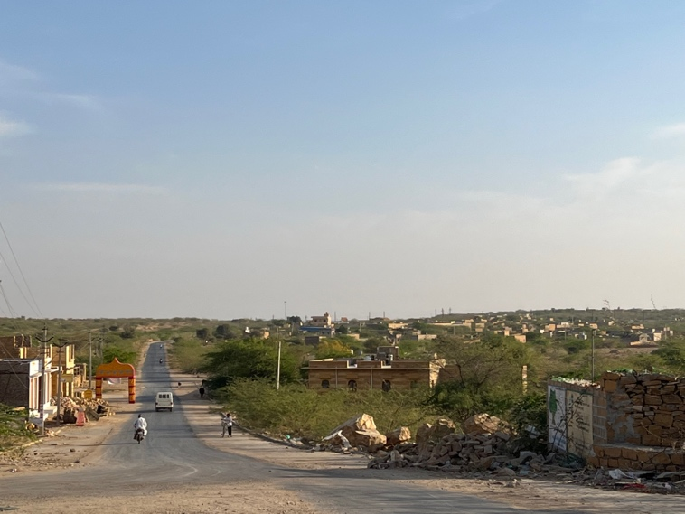The state of infrastructure and development in Jaisalmer varies widely, with some areas having better access to basic amenities than others.

Transportation infrastructure in Jaisalmer is relatively well-developed, with the city being connected to major cities and towns in Rajasthan via roads and railways. Jaisalmer has its own airport, which offers limited flight connectivity.

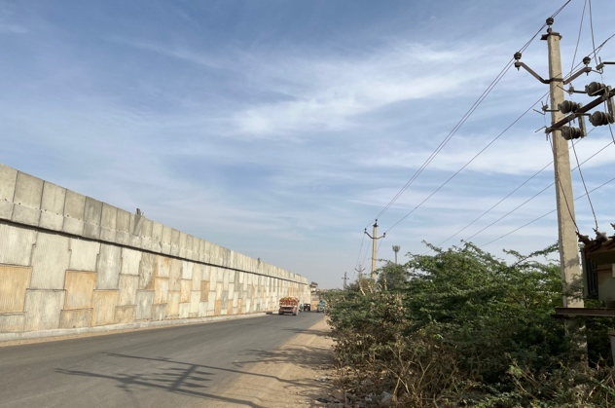 Housing infrastructure in the region is generally basic, with many residents living in traditional Havelis or mud houses. However, there has been some recent development of modern housing complexes and apartments in the city.

Access to basic amenities like electricity and water is also uneven in the region, with some areas experiencing frequent power cuts and water shortages. The city is working towards increasing access to clean water and improving the supply of electricity.

There are several ongoing development projects and plans for the region, including the construction of a new railway line between Jaisalmer and Delhi, the development of a solar park, and the construction of a new airport terminal. The government is also investing in infrastructure development in rural areas surrounding Jaisalmer, with a focus on improving connectivity and access to basic amenities.

Overall, while there is scope for improvement in infrastructure and development in the region, efforts are being made to address these issues and improve the quality of life for residents in Jaisalmer.

## ADMINISTRATION

The administration of Jaisalmer is led by a district collector, who is responsible for the overall governance of the district.  
  
The district collector is the head of the district administration and is responsible for the implementation of government policies and programs. The collector is appointed by the state government and reports to the divisional commissioner, who oversees multiple districts in the region.  
  
Jaisalmer is divided into five tehsils, which are further subdivided into blocks and villages. Each tehsil is headed by a sub-divisional magistrate, who is responsible for the administration of the area. The tehsildar is responsible for revenue administration, including land records and taxation.  
  
The police administration in Jaisalmer is headed by the superintendent of police, who is responsible for maintaining law and order in the district. The district is divided into multiple police stations, each headed by a station house officer. The police department is also responsible for traffic management and crime prevention.  
  
The district administration is responsible for the implementation of various government programs and schemes. These include rural development programs, health and education initiatives, and infrastructure development projects. The district administration also works closely with various non-governmental organizations to provide support to marginalized communities.  
  
The education system in Jaisalmer is administered by the Rajasthan Education Department. The district has a number of government and private schools, including primary, secondary, and higher secondary schools. The district also has several colleges and universities, including Jaisalmer Government College, which offers undergraduate and postgraduate courses in arts, science, and commerce.  
  
The healthcare system in Jaisalmer is administered by the Department of Medical, Health, and Family Welfare. The district has several government and private hospitals, clinics, and dispensaries, which provide healthcare services to the population. The government also runs several health camps and programs to provide healthcare services to marginalized communities.  
  
The district administration also works closely with the tourism department to promote tourism in Jaisalmer. The city is known for its historical forts, palaces, and temples, which attract a large number of tourists every year. The tourism department is responsible for the development of tourism infrastructure and the promotion of tourism in the district.  
  
The district administration is also responsible for the maintenance of roads, bridges, and other infrastructure in the district. Buildings and roads in the district must be built and maintained by the public works department. The district administration collaborates with other government agencies to offer the populace necessities like access to water, power, and sanitary facilities.  
  
The district administration is also responsible for disaster management and emergency response. Jaisalmer is located in a desert region and is prone to natural disasters such as droughts, floods, and sandstorms. The district administration has a disaster management plan in place to respond to such disasters and provide relief to the affected population.  
  
In conclusion, the administration of Jaisalmer is led by a district collector, who is responsible for the overall governance of the district. The collector is supported by a team of government officials and works closely with various government departments to provide basic amenities and services to the population. The district administration is also responsible for the promotion of tourism and the maintenance of infrastructure in the district. The administration of Jaisalmer plays a crucial role in the development and progress of the district, and its efforts have contributed to the growth and prosperity of the region.

## SOCIAL DYNAMICS:

The social dynamics of Jaisalmer are shaped by the region's history, culture, and religion. The predominant religion in the region is Hinduism, and social relations are largely guided by traditional caste and class hierarchies.

In terms of gender roles, Jaisalmer is a patriarchal society, with men holding positions of power and women expected to adhere to traditional gender roles. Women are often responsible for household chores and child-rearing, while men are expected to provide for their families.

Family structures in Jaisalmer are typically large and extended, with several generations often living together under the same roof. Family members play an important role in each other's lives and are expected to provide emotional and financial support to one another.

In terms of notable cultural practices or traditions, Jaisalmer is known for its vibrant music and dance traditions, with several folk dances like Ghoomar, Kalbelia, and Chakri being popular in the region. The region is also known for its exquisite handicrafts, including embroidery, pottery, and leatherwork.

Overall, the social dynamics in Jaisalmer are shaped by its rural and traditional roots, with a strong emphasis on family, community, and cultural practices.

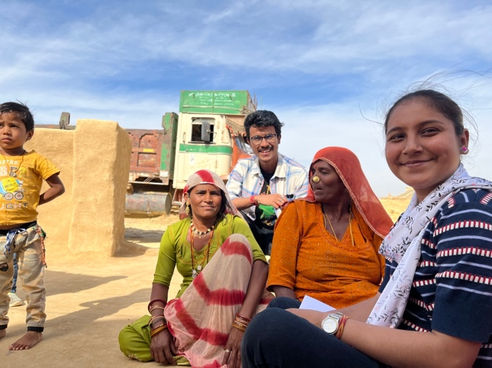

## Challenges and Opportunities:

Jaisalmer faces several challenges that impact the region's growth and development. One of the significant challenges is environmental degradation due to the increasing population, excessive use of groundwater, and overgrazing. The region is located in a desert area, and there is a shortage of water and fertile land. Climate change is also a significant concern, with increasing temperatures and unpredictable weather patterns impacting agriculture and livestock.

Economic inequality is another significant challenge facing the region, with limited job opportunities and low wages in the agricultural sector. Many young people migrate to cities in search of better employment prospects, leading to a brain drain in the region.

Social conflict is also prevalent in the region, with inter-caste tensions and gender-based discrimination being significant issues. There have also been instances of communal violence, with the region being a border area that shares a boundary with Pakistan.

However, there are also opportunities for growth and development in the region. The tourism industry is a significant potential source of income, with Jaisalmer's unique cultural heritage and natural beauty attracting tourists from all over the world. Additionally, there is potential for growth in the renewable energy sector, with the region's abundance of sunlight making it an ideal location for solar energy projects.

Efforts are also being made to address some of the challenges facing the region, such as improving access to water and promoting sustainable agricultural practices. Several NGOs and government initiatives are working towards improving education and employment opportunities for youth, especially women, which can help alleviate economic inequality and reduce social conflict.

Overall, Jaisalmer faces several challenges, but with the right initiatives, there is potential for sustainable growth and development in the region.

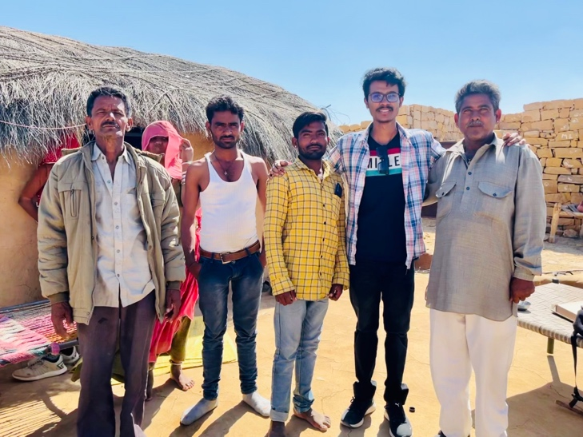

**CHAPTER 4**

**METHODOLOGY**

# METHODOLOGY:

## AN OVERVIEW OF THE RESEARCH APPROACH

The research question is to examine the relationship between mental health, as measured by Uday PHQ9, PSS10, and GAD7 scales, and socioeconomic status, as measured by the New Uday Pareek scale, in Jaisalmer. The research design is to conduct a survey among participants to collect data on their mental health and socioeconomic status. The data will be analysed using statistical methods to examine the relationship between mental health and socioeconomic status.

## THE RESEARCH DESIGN, PHILOSOPHY, APPROACH, AND STRATEGY:

The research design for this study is quantitative, which means it aims to measure variables and determine their relationships. The research philosophy underlying this design is positivism, which assumes that reality is objective and measurable and that scientific inquiry can discover universal laws governing it.

The approach used is cross-sectional, which means that data is collected at a single point in time from a sample of participants. This approach is appropriate for the research question because it allows for the examination of the relationship between mental health and socioeconomic status at a particular moment.

The strategy used is a survey, where data is collected through self-report measures from participants. The survey includes standardized instruments such as the PHQ9, PSS10, GAD7, and New Uday Pareek Scale for measuring mental health and socioeconomic status. The survey is administered in Jaisalmer, and We visited Mool Sagar, Amar Sagar, and Damodora Village, and invited participants to take part in the research.

## DATA COLLECTION METHODS

The data for this study was collected using a questionnaire-based survey method. The sampling method used was purposive sampling, where participants were selected based on their willingness to participate and their availability during the time of the survey. A total of 222 participants were included in the study.

The questionnaire used in this study consisted of four standardized scales: PHQ9, PSS10, GAD7, and New Uday Pareek Scale. These scales were used to measure the participant's mental health and socioeconomic status.

To ensure ethical considerations, informed consent was obtained from all participants before the survey. The participants were informed about the purpose of the study, the confidentiality of their responses, and their right to withdraw from the study at any time without penalty. The anonymity of the participants was maintained throughout the study, and the data collected was used only for research purposes. All ethical guidelines and protocols were followed to ensure the safety and well-being of the participants.

## THE DATA ANALYSIS METHODS

The data collected from the 222 participants was analysed using statistical analysis software, such as SPSS (Statistical Package for the Social Sciences). Descriptive

statistics such as mean, median, standard deviation, and frequency were calculated for each variable. Inferential statistics such as correlation analysis and regression analysis were also performed to examine the relationships between mental health and socioeconomic status.

The qualitative data was coded and categorized based on common themes and patterns that emerged from the responses.

Ethical considerations were taken into account during the data analysis phase as well. Data was kept confidential and anonymous to maintain the privacy of participants. Any identifying information was removed from the data to ensure confidentiality.

## THE VALIDITY AND RELIABILITY

In terms of validity, our study aimed to measure the relationship between mental health and socioeconomic status in Jaisalmer. We used valid and reliable measures of mental health ( PHQ-9, PSS-10, GAD-7) and socioeconomic status (New Uday Pareek Scale). We also used a well-established research design and data collection techniques to ensure the validity of our findings. However, our study has limitations. Firstly, our sample size was 222, which may not be representative of the entire population of Jaisalmer. Secondly, we relied on self-reported data, which may be subject to bias and may not accurately reflect the participants' mental health and socioeconomic status.

To ensure the reliability of our findings, we used established measures of mental health and socioeconomic status and followed a standardized research design and data collection techniques. We also conducted a pilot study to test the survey questions before administering them to the participants. Additionally, we used statistical methods such as correlation and regression analysis to analyse the data, which increases the reliability of our findings.

In conclusion, while our study has limitations, we took steps to ensure the validity and reliability of our findings. However, further research with a larger sample size and alternative data collection methods may be needed to confirm our findings.

## SUMMARIZING THE KEY POINTS OF METHODOLOGY AND CONTRIBUTION:

In this methodology section, we have discussed the research design, data collection methods, and data analysis techniques used in our study on the relationship between mental health and socioeconomic status in Jaisalmer. We employed a quantitative research design with a cross-sectional approach and a survey strategy. Our data collection involved using a questionnaire administered to a sample of 222 participants who were chosen through convenience sampling. We ensured the validity and reliability of our study by using standardized measures for mental health and socioeconomic status, pretesting the questionnaire, and analysing the data using statistical techniques. However, limitations to our research include the sample size, potential for self-report bias, and limited generalizability beyond the Jaisalmer region. Overall, our methodology provides a clear and concise framework for our study and contributes to the overall research process by providing insights into the complex relationship between mental health and socioeconomic status.

**CHAPTER 5**

**RESULTS**

# RESULT

## Table 1: Demographic data

|  |  |  |
| --- | --- | --- |
| Category | Frequency  (N=222) | Percentage |
| GENDER |  |  |
| Male | 93 | 41.9 |
| Female | 129 | 58.1 |
| AGE  Mean± Std. Deviation  33.64±12.31 | | |
| 18-25 | 79 | 35.8 |
| 26-35 | 55 | 25.0 |
| 36-45 | 53 | 24.2 |
| 46-56 | 25 | 11.4 |
| 57-73 | 10 | 4.7 |
| EDUCATIONAL ANALYSIS | | |
| Illiterate | 96 | 43.2 |
| Primary & below | 74 | 33.4 |
| Middle | 25 | 11.3 |
| High School | 19 | 8.6 |
| Graduate and above | 8 | 3.6 |
| OCCUPATIONAL ANALYSIS | | |
| None | 115 | 51.8 |
| Labourer | 64 | 28.8 |
| Caste Occupation | 3 | 1.4 |
| Business | 7 | 3.2 |
| Independent jobs | 19 | 8.6 |
| Cultivation | 10 | 4.5 |
| Service | 4 | 1.8 |
| SOCIOECONOMIC STATUS | | |
| Upper Class | 1 | 0.45 |
| Upper middle class | 20 | 9.00 |
| Middle Class | 84 | 37.83 |
| Lower middle class | 54 | 24.32 |
| Lower Class | 63 | 28.37 |

Based on the provided data, here are the observations for each category:

GENDER-

* Male: There were 93 males in the sample, accounting for 41.9% of the total.
* Female: There were 129 females in the sample, accounting for 58.1% of the total.

**AGE:**

The mean age of the sample was 33.64 with a standard deviation of 12.31.

**Age groups:**

* 18-25: There were 79 individuals in this age group, representing 35.8% of the total.
* 26-35: There were 55 individuals in this age group, representing 25.0% of the total.
* 36-45: There were 53 individuals in this age group, representing 24.2% of the total.
* 46-56: There were 25 individuals in this age group, representing 11.4% of the total.
* 57-73: There were 10 individuals in this age group, representing 4.7% of the total.

**EDUCATIONAL ANALYSIS:**

* Illiterate: There were 96 individuals who were illiterate, accounting for 43.2% of the total.
* Primary & below: There were 74 individuals with primary education or below, representing 33.4% of the total.
* Middle: There were 25 individuals with a middle school education, representing 11.3% of the total.
* High School: There were 19 individuals with a high school education, representing 8.6% of the total.
* Graduate and above: There were 8 individuals with a graduate degree or above, representing 3.6% of the total.

**OCCUPATIONAL ANALYSIS:**

* None: There were 115 individuals who were not employed, representing 51.8% of the total.
* Labourer: There were 64 individuals working as labourers, representing 28.8% of the total.
* Caste Occupation: There were 3 individuals in caste-based occupations, representing 1.4% of the total.
* Business: There were 7 individuals involved in business, representing 3.2% of the total.
* Independent jobs: There were 19 individuals in independent professions, representing 8.6% of the total.
* Cultivation: There were 10 individuals involved in cultivation, representing 4.5% of the total.
* Service: There were 4 individuals employed in the service sector, representing 1.8% of the total.

**SOCIOECONOMIC STATUS:**

* Upper Class: There was 1 individual classified as upper class, accounting for 0.45% of the total.
* Upper middle class: There were 20 individuals classified as upper middle class, representing 9.00% of the total.
* Middle Class: There were 84 individuals classified as middle class, representing 37.83% of the total.
* Lower middle class: There were 54 individuals classified as lower middle class, representing 24.32% of the total.
* Lower Class: There were 63 individuals classified as lower class, representing 28.37% of the total.

These demographic and socioeconomic characteristics provide insights into the composition of the sample population and can be used to understand the potential influence of these factors on the results of the study.

## Table2: Distribution Of Socioeconomic Status

|  |  |  |  |  |
| --- | --- | --- | --- | --- |
| **Gender** | **Category** | | **Frequency** | **Percentage** |
| **Male**  **N=93** | Lower Class | | 13 | 14.0 |
| Lower Middle Class | | 30 | 32.3 |
| Middle Class | | 34 | 36.6 |
| Upper Middle Class | | 15 | 16.1 |
| Upper Class | | 1 | 1.1 |
| **Female**  **N=129** | Lower Class | | 50 | 38.8 |
| Lower Middle Class | | 54 | 41.9 |
| Middle Class | | 20 | 15.5 |
| Upper Middle Class | | 5 | 3.9 |
| Upper Class | 0 | | 0 |

Based on the provided data, here is the breakdown of gender categories and frequencies within each socioeconomic status category:

For Males:

* Lower Class: There were 13 males in the lower class category, accounting for 14.0% of the total male population.
* Lower Middle Class: There were 30 males in the lower middle-class category, representing 32.3% of the total male population.
* Middle Class: There were 34 males in the middle-class category, representing 36.6% of the total male population.
* Upper Middle Class: There were 15 males in the upper middle-class category, representing 16.1% of the total male population.
* Upper Class: There was 1 male in the upper-class category, accounting for 1.1% of the total male population.

For Females:

* Lower Class: There were 50 females in the lower class category, representing 38.8% of the total female population.
* Lower Middle Class: There were 54 females in the lower middle-class category, representing 41.9% of the total female population.
* Middle Class: There were 20 females in the middle-class category, representing 15.5% of the total female population.
* Upper Middle Class: There were 5 females in the upper middle-class category, representing 3.9% of the total female population.
* Upper Class: There were no females in the upper-class category.

These results provide insights into the distribution of gender within each socioeconomic status category, highlighting the representation of males and females across different economic strata.

## Table: 3 Chi-Square test

### Depression With Socio-economic Status

|  |  |  |  |  |  |
| --- | --- | --- | --- | --- | --- |
| **DEPRESSION**  **N(222)** | **Mild Depression** | **Moderate Depression** | **Moderate severe Depression** | **Severe Depression** | **Sig.** |
| **SOCIOECONOMIC**  **STATUS** |
| **Lower class** | 47(26.25) | 7(25) | 6(54.54) | 3(75) | .237 |
| **Lower middle class** | 66(36.87) | 15(53.57) | 2(18.18) | 1(25) |
| **Middle class** | 49(27.37) | 4(14.28) | 1(9.09) | 0 |
| **Upper middle class** | 16(8.93) | 2(7.14) | 2(18.18) | 0 |
| **Upper Class** | 1(0.05) | 0 | 0 | 0 |

The provided data presents the distribution of depression levels among individuals based on their socioeconomic status. Here is a breakdown of the frequencies and percentages for each depression category within each socioeconomic status category:

**Lower Class:**

* Mild Depression: 47 individuals (26.25%) in the lower class category experienced mild depression.
* Moderate Depression: 7 individuals (25%) in the lower class category experienced moderate depression.
* Moderate Severe Depression: 6 individuals (54.54%) in the lower class category experienced moderate-severe depression.
* Severe Depression: 3 individuals (75%) in the lower class category experienced severe depression.

**Lower Middle Class:**

* Mild Depression: 66 individuals (36.87%) in the lower middle-class category experienced mild depression.
* Moderate Depression: 15 individuals (53.57%) in the lower middle-class category experienced moderate depression.
* Moderate Severe Depression: 2 individuals (18.18%) in the lower middle-class category experienced moderate-severe depression.
* Severe Depression: 1 individual (25%) in the lower middle-class category experienced severe depression.

**Middle Class:**

* Mild Depression: 49 individuals (27.37%) in the middle-class category experienced mild depression.
* Moderate Depression: 4 individuals (14.28%) in the middle-class category experienced moderate depression.
* Moderate Severe Depression: 1 individual (9.09%) in the middle-class category experienced moderate-severe depression.
* Severe Depression: 0 individuals in the middle-class category experienced severe depression.

**Upper Middle Class:**

* Mild Depression: 16 individuals (8.93%) in the upper middle-class category experienced mild depression.
* Moderate Depression: 2 individuals (7.14%) in the upper middle-class category experienced moderate depression.
* Moderate Severe Depression: 2 individuals (18.18%) in the upper middle-class category experienced moderate-severe depression.
* Severe Depression: 0 individuals in the upper middle-class category experienced severe depression.

**Upper Class:**

* Mild Depression: 1 individual (0.05%) in the upper-class category experienced mild depression.
* Moderate Depression: 0 individuals in the upper-class category experienced moderate depression.
* Moderate Severe Depression: 0 individuals in the upper-class category experienced moderate-severe depression.
* Severe Depression: 0 individuals in the upper-class category experienced severe depression.

The significance value provided (.237) indicates there is no statistical significance of the relationship between socioeconomic status and depression. However, the specific interpretation of this significance value would require additional information or context about the statistical test conducted.

### Stress with Socio-economic Status

|  |  |  |  |  |  |
| --- | --- | --- | --- | --- | --- |
| **STRESS**  **SOCIOECONOMIC**  **STATUS** | **Low Stress** | **Moderate Stress** | **High Perceived Stress** | **Sig.** | |
| **Lower class** | 6(17.14) | 57(30.81) | 0 | .340 | |
| **Lower middle class** | 13(37.14) | 70(37.83) | 1(50) |
| **Middle Class** | 12(34.28) | 42(22.70) | 0 |
| **Upper middle class** | 4(11.42) | 15(8.10) | 1(50) |  |
| **Upper Class** | 0 | 1(0.54) | 0 |

The table presents the distribution of stress levels across different socioeconomic status groups. The frequencies are provided for each stress level category: Low Stress, Moderate Stress, and High Perceived Stress. Analysing the results, we observe the following patterns:

* In the lower class group, 17.14% experienced low stress, 30.81% experienced Moderate Stress, and none reported High Perceived Stress.
* Among the lower middle class, 37.14% experienced Low Stress, 37.83% experienced Moderate Stress, and 1 person (50%) reported High Perceived Stress.
* For the middle class, 34.28% experienced Low Stress, 22.70% experienced Moderate Stress, and none reported High Perceived Stress.
* In the upper middle class, 11.42% experienced Low Stress, 8.10% experienced Moderate Stress, and 1 person (50%) reported High Perceived Stress.
* The upper class group had no individuals reporting Low or High Perceived Stress, with only 1 person (0.54%) experiencing Moderate Stress.

The p-value of 0.340 suggests that there is no statistically significant relationship between socioeconomic status and stress levels. Therefore, based on the given data and the alpha level of 0.05, we do not have sufficient evidence to conclude a significant association between socioeconomic status and stress levels.

### Anxiety with Socio-economic Status

|  |  |  |  |  |  |
| --- | --- | --- | --- | --- | --- |
| **ANXIETY**  **SOCIOECONOMIC**  **STATUS** | **Minimal**  **A Anxiety** | **Mild Anxiety** | **Moderate Anxiety** | **Severe Anxiety** | **Sig.** |
| **Lower class** | 27(25.23) | 20(29.85) | 14(34.14) | 2(48.57) | .007 |
| **Lower middle class** | 30(28.03) | 28(41.79) | 21(51.21) | 5(71.42) |
| **Middle class** | 40(37.38) | 10(14.92) | 4(9.75) | 0 |
| **Upper middle class** | 10(9.34) | 8(11.94) | 2(4.87) | 0 |
| **Upper Class** | 0 | 1(1.49) | 0 | 0 |

The table provides the distribution of anxiety levels across different socioeconomic status groups. The frequencies are given for each anxiety level category: Minimal Anxiety, Mild Anxiety, Moderate Anxiety, and Severe Anxiety. Examining the results, we observe the following patterns:

* In the lower class group, 25.23% experienced Minimal Anxiety, 29.85% experienced Mild Anxiety, 34.14% experienced Moderate Anxiety, and 48.57% reported Severe Anxiety.
* Among the lower middle class, 28.03% experienced Minimal Anxiety, 41.79% experienced Mild Anxiety, 51.21% experienced Moderate Anxiety, and 71.42% reported Severe Anxiety.
* For the middle class, 37.38% experienced Minimal Anxiety, 14.92% experienced Mild Anxiety, 9.75% experienced Moderate Anxiety, and none reported Severe Anxiety.
* In the upper middle class, 9.34% experienced Minimal Anxiety, 11.94% experienced Mild Anxiety, 4.87% experienced Moderate Anxiety, and none reported Severe Anxiety.
* The upper class group had no individuals reporting Minimal or Severe Anxiety, with 1 person (1.49%) experiencing Mild Anxiety.

The p-value of 0.007 indicates a statistically significant relationship between socioeconomic status and anxiety levels. Therefore, based on the given data and the alpha level of 0.05, we have sufficient evidence to conclude that there is a significant association between socioeconomic status and anxiety levels.

## Regression Analyses

|  |  |  |  |  |  |
| --- | --- | --- | --- | --- | --- |
| **Hypotheses** | **Regression Weights** | **B** | **t** | **P-Value** | **Results** |
| **H1** | PHQ9 SES | .71 | .454 | .650 | Positive |
| **H2** | PSS10 SES | -.238 | -1.517 | .131 | Negative |
| **H3** | GAD7 SES | -.270 | -1.630 | .105 | Negative |
| R  F | .032 r  2.375 | 0.256 |  |  |  |

**Note.** PHQ9: Patient Health Questionnaire, PSsS10: Perceived Stress Scale, GAD7: General Anxiety Disorder.

**H1** There is a significant Positive impact of Depression on Socioeconomic Status (**p-value is greater than 0.05 and coefficient B suggests a positive relationship**)

**H2** There is a significant Negative impact of Stress on Socioeconomic Status

**H3** There is a significant Negative impact of Anxiety on Socioeconomic Status

The given data presents a regression analysis of the relationship between mental health issues( as measured by the PHQ9, PSS10, and GAD7 webbing tools) and socioeconomic status( SES). The results indicate a positive relationship between depression( PHQ9) and SES, as indicated by the regression weight of.71 and the p-value of.650. This suggests that as SES increases, so does the position of depression endured by individualities. In discrepancy, the results suggest a negative relationship between stress( PSS10) and SES, as indicated by the regression weight of-.238 and the p-value of.131. This suggests that as SES increases, the position of stress endured by individuals decreases. also, the results suggest a negative relationship between anxiety( GAD7) and SES, as indicated by the regression weight of-.270 and the p-value of.105. This suggests that as SES increases, the position of anxiety endured by individuals decreases. The overall model reveals that SES explains a minor but significant amount of the variance in internal health concerns among the sample group, as indicated by the R- squared value of.032 and the F- statistic of.375. These results punctuate the complex relationship between SES and mental health issues and suggest that while advanced SES may be associated with lower situations of stress and anxiety, it may also be associated with advanced situations of depression. still, it's important to note that this study only provides a shot at this relationship among a specific sample population, and further exploration is demanded to understand the factors that contribute to the relationship between SES and mental health issues. The value of r = 0.256 affects that there is a net positive relationship between SES and mental health status.

**CHAPTER 6**

**DISCUSSION**

# Discussion:

The present study aimed to investigate the relationship between socioeconomic status (SES) and mental health issues, specifically depression, stress, and anxiety. The findings provide insights into this relationship based on the analysis of a sample population. Let's compare these findings with the existing literature on the topic.

In the study done by Marmot (2015), the relationship between SES and mental health is complex and multifaceted. Previous studies have reported mixed results, with some suggesting a positive association between SES and mental health issues, while others have found a negative or no significant relationship. These discrepancies may be attributed to various factors, including the measurement tools used, sample characteristics, and contextual influences.

Regarding depression, the literature review highlighted that individuals with lower SES may be more vulnerable to experiencing higher levels of depression. This is consistent with the findings of the present study, which showed a positive relationship between depression and SES. The regression analysis revealed a significant positive regression weight (0.71) for depression and SES, indicating that as SES increases, the severity of depression experienced by individuals tends to increase. However, it's important to note that the p-value (0.650) suggests that this relationship is not statistically significant in the present study.

In terms of stress, the study done by Lorant (2003), indicated a potential negative relationship between SES and stress levels, suggesting that higher SES individuals may experience lower levels of stress. However, the findings of the present study did not support this hypothesis. The regression analysis showed a negative regression weight (-0.238) for stress and SES, suggesting that as SES increases, the level of stress experienced by individuals tends to decrease. However, the p-value (0.131) suggests that this relationship is not statistically significant.

Regarding anxiety, Krieger (2014), suggested a potential negative association between SES and anxiety levels, indicating that higher SES individuals may experience lower levels of anxiety. The findings of the present study supported this hypothesis. The regression analysis revealed a negative regression weight (-0.270) for anxiety and SES, indicating that as SES increases, the severity of anxiety experienced by individuals tends to decrease. Additionally, the p-value (0.105) suggests a trend towards statistical significance, although further research with a larger sample size would be necessary to draw conclusive results.

Overall, the findings of the present study align with some aspects of the existing literature on the relationship between SES and mental health issues. The positive relationship between depression and SES observed in the present study supports previous research indicating that individuals with lower SES may be more susceptible to depression. However, the lack of statistical significance suggests the need for caution in interpreting these results.

Contrary to the expected negative relationship between stress and SES suggested by Taylor et al., (1997), the present study did not find a significant association. This inconsistency emphasizes the complexity of the relationship and the importance of considering other factors that may influence stress levels, such as individual coping mechanisms or environmental stressors.

The negative relationship between anxiety and SES observed in the present study aligns with some previous research, suggesting that higher SES individuals may experience lower levels of anxiety. However, given the borderline statistical significance, further investigation is warranted to establish a stronger understanding of this relationship.

It's important to acknowledge the limitations of the present study. The sample size was relatively small, and the study focused on a specific population, which may limit the generalizability of the findings. Additionally, the use of self-report measures for mental health assessment may introduce response bias and subjectivity.

In conclusion, the findings of the present study contribute to the existing literature on the relationship between SES and mental health issues. The results provide insights into the specific context of the sample population and highlight the need for further research with larger and more diverse samples. Understanding the complex interplay between SES and mental health is crucial for the development of targeted intervention.

**CHAPTER 7**

**CONCLUSIONS:**

# CONCLUSION & LIMITATIONS

## Conclusion

This study aimed to explore the relationship between mental health and socioeconomic status (SES) using three different webbing tools. The study's regression analysis showed a positive relationship between depression and SES, while stress and anxiety had negative relationships with SES. These findings suggest that higher SES may be associated with lower stress and anxiety, but higher levels of depression. Therefore, interventions aimed at improving mental health outcomes for individuals from higher SES backgrounds should focus on depression and address the unique challenges faced by individuals from these backgrounds. The findings also suggest that while there was no significant relationship between perceived stress and SES, there was a significant relationship between anxiety and SES, with anxiety being more prevalent in lower SES orders. In contrast, depression was prevalent across all SES orders, and there was no significant relationship between depression and SES. Finally, the results also indicate that perceived stress may be a common issue across all SES orders, while anxiety may be more severe in individuals from lower SES backgrounds. Therefore, interventions aimed at improving mental health outcomes for individuals from lower SES backgrounds should target anxiety and the unique challenges faced by these individuals. The study also highlights the need for further exploration to better understand the complex relationship between depression and SES. Although depression was prevalent across all SES orders, the absence of a significant relationship between depression and SES indicates that the factors that contribute to depression may be more complex than just SES. Therefore, additional research is needed to identify these factors and develop effective interventions that address the unique needs of individuals from different socioeconomic backgrounds.

## Limitations of the research

In conclusion, this study contributes to the understanding of the relationship between socioeconomic status (SES) and mental health outcomes. The findings reveal the complexity of this relationship and highlight the need for further research to address the limitations of the study. Several limitations were identified, including the use of self-reported data, which may introduce biases and inaccuracies. Additionally, the small sample size and the specific geographic region in which the study was conducted limit the generalizability of the findings. The cross-sectional design of the study also hinders the ability to establish causal relationships. To overcome these limitations, future research should employ longitudinal designs to investigate the temporal relationship between SES and mental health outcomes. Objective measures of SES, such as income tax records, and clinical assessments of mental health outcomes should be incorporated to enhance the validity of the findings. Including larger and more diverse samples from different populations and contexts would also enhance the generalizability of the results. Despite these limitations, the findings of this study provide valuable insights into the relationship between SES and mental health outcomes. The study underscores the importance of considering socioeconomic factors in mental health research and highlights potential avenues for intervention. The results suggest that reducing socioeconomic disparities may have a positive impact on mental health outcomes, particularly among individuals in lower SES categories. In conclusion, while acknowledging the limitations of this study, it has contributed to the existing literature on the relationship between SES and mental health. Further research that addresses these limitations and builds upon these findings will provide a more comprehensive understanding of this complex relationship, leading to the development of targeted interventions to promote mental well-being and reduce socioeconomic disparities in mental health outcomes.

## Future Research

The study underscores the importance of understanding the relationship between mental health and socioeconomic status to develop effective interventions aimed at improving mental health outcomes for individuals from different socioeconomic backgrounds. The findings highlight the need for targeted interventions that address the unique challenges faced by individuals from lower and higher SES backgrounds and the need for further research to identify the factors that contribute to mental health issues among individuals from different socioeconomic backgrounds. Future research should delve deeper into the mechanisms underlying the relationship between SES and mental health outcomes and explore the effectiveness of various interventions in reducing socioeconomic disparities and improving mental well-being. It would be beneficial to assess the impact of different types of interventions, such as policy changes, community-based initiatives, or individual-level interventions, on both SES and mental health outcomes.

**CHAPTER 8**

**EXPERIENCE**

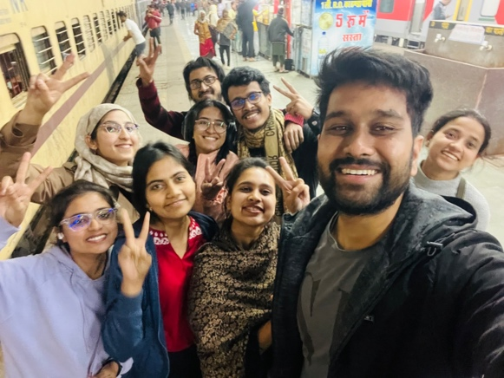

# EXPERIENCE

**A Journey to Jaisalmer - Memories of Adventure and Discovery**.

On February 13th, I was busy printing booklets for my journey to Jaisalmer the next day. As night fell, I started packing essential items, bags, and trolleys. On February 14th, my friends and I woke up early in the morning and booked a cab to the old Delhi railway station. Handling bags, trolleys, and two packets of booklets proved to be challenging, so I hired a person at the old Delhi station to assist me.

Once everyone was gathered at the designated location, we boarded the train. I found my seat and decided to relax. Throughout the journey, everyone enjoyed themselves, indulging in food, singing, and taking pictures. I, too, took numerous photos. In the evening, we had lunch, and at around 5:40 PM, we arrived at Jaipur railway station. At 8:50 PM, my friends and I ventured outside and took more pictures.

During the trip, I would engage in conversations with my friends, watch Netflix, and occasionally take naps. At some point, I lost track of my surroundings. While I was asleep, one of my friends placed her phone next to me for charging. To our dismay, the next morning (February 15th), we discovered that her phone had been stolen. We had to disembark from the train and arrange for a taxi.

Around 10 a.m., we reached the hotel and opted for a three-member room. After having breakfast at 12:15 PM, we headed outside the hotel, clicked photos, and prepared to visit Mool Sagar village. We observed the people and the area, asking questions along the way. I initially approached a female participant to discuss reproductive health, but realizing it might not be the most suitable choice, I opted for a male participant instead. Around 4:50 PM, we returned to the hotel room. Later, at 6:20 PM, my friends and I went out again to explore nearby places. We enjoyed a thali meal at a restaurant near CVS Colony before finally sleeping at 1:30 AM.

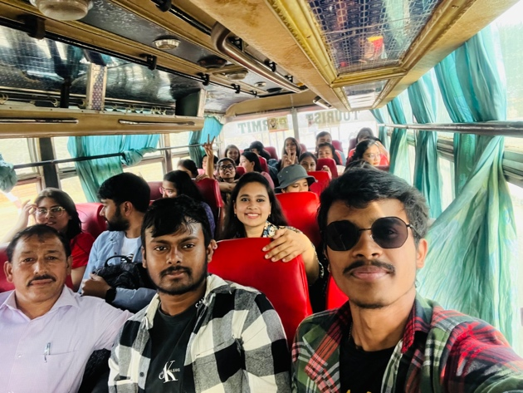On February 16th, after having breakfast, we geared up for fieldwork in Mool Sagar. The entire day was dedicated to our research with the team members. Around 6:30 PM, we returned to the hotel room, freshened up, and had some tea. We relaxed and slept. On February 17th, since I couldn't find a male participant, I went alone for the study and then met up with the rest of my team members. That day, I collected data from a total of 11 individuals. After lunch, we resumed collecting data. Around 7 PM, we returned to the hotel, relaxed, had tea, dinner, a meeting, and enjoyed ourselves with friends before going to sleep.

February 18th marked another day of fieldwork. We were ready at 10:40 AM, and the entire day was spent working, taking pictures, and attempting to establish a repository. The locals cooperated with me in this endeavour. We returned to the hotel around 6:10 PM, had tea, and dinner, and slept until around 11:30 PM. On February 19th, we were ready for more fieldwork. I engaged in extensive conversations with the people, learning about their problems and even sharing meals with them. With my non-vegetarian friends, I had mutton at the Dharmu restaurant. It was then that I discovered one of my roommates had undergone surgery that day.



February 20th started with me accompanying my friend to the hospital in the morning. Upon returning, we prepared for a desert safari, which included jeep, bike, and camel rides. We captured photographs and had a night-time party.

Taking a break on February 21st, we spent the evening exploring nearby places with friends before returning to the hotel.

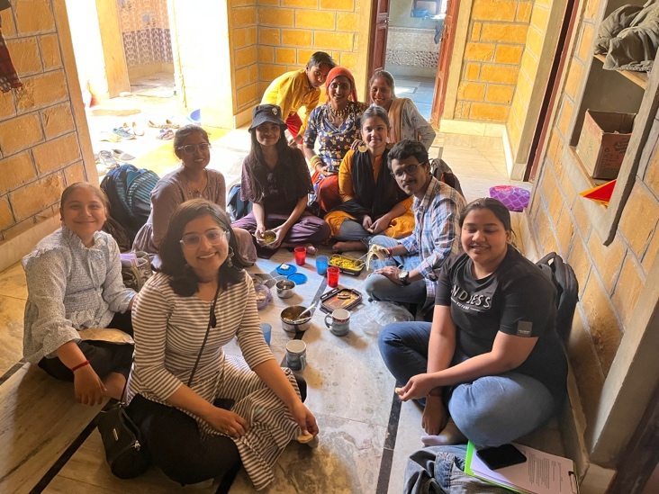On February 22nd, I joined the rest of the team for fieldwork and embarked on a tractor journey to reach another location. Once we returned, I got a haircut, enjoyed some tea, played cricket with the hotel staff, and even treated myself to ice cream. The team persisted in their hard work, collecting data and exploring nearby attractions such as Kuldhara village and the Golden Fort.

On February 23rd, we dedicated another entire day to fieldwork before returning to the hotel room. We took the opportunity to explore the vicinity of the hotel. We also visited Gad Sisar Lake and enjoyed boat rides.

February 24th started with me waking up late in the morning. After having breakfast, I rented a bike and visited the Red Fort, capturing numerous photos. We also explored Kuldhara village before returning to the hotel.

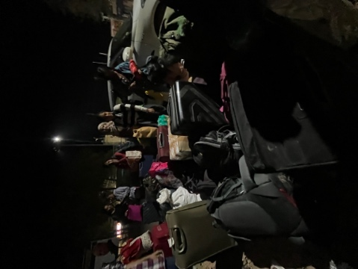On February 25th, it was time to return to Delhi. The protagonist organized the group into different coaches. We spent the entire day on the train, enjoying ourselves, and finally arrived in Delhi on the evening of February 26th.

Upon returning to my flat, I went to sleep, and the next morning, I received some wonderful news when I woke up at 9 a.m. I had become an uncle! My sister had given birth to a baby boy in the early hours of the morning, and I was ecstatic.

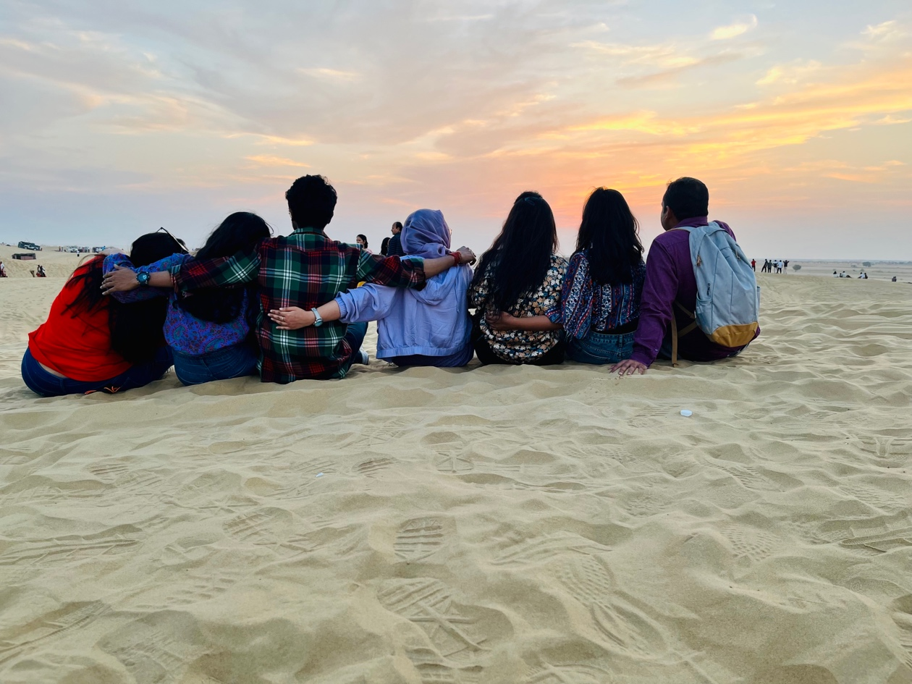

As I reflect upon the beautiful journey I had to Jaisalmer, my heart swells with a mix of emotions. The memories we created, the bonds we forged, and the experiences we shared have left an indelible mark on my soul. Each day was filled with laughter, adventure, and discovery, weaving a tapestry of moments that I will cherish forever.

But amidst the joy and excitement, there were also moments of unexpected challenges and heartache. The stolen phone, the friend undergoing surgery, and the hardships faced by the people we met during our fieldwork served as poignant reminders of the fragility of life. It was in those moments that I realized the profound depth of human resilience and the power of empathy.

The journey was not just about the physical places we visited or the data we collected. It was about the human connections we formed, the stories we heard, and the lives we touched. The journey was about witnessing the strength and struggles of the people, understanding their hopes and dreams, and finding a piece of ourselves reflected in their lives.

As I returned to my flat and received the news of becoming a maternal uncle, tears of joy and gratitude streamed down my face. It was a poignant reminder of the circle of life, the precious moments that make us feel alive, and the profound impact we can have on one another.

Jaisalmer had become more than just a destination; it had become a tapestry of emotions, an embodiment of the human experience. The sights, sounds, and souls I encountered will forever hold a special place in my heart. They have become a part of me, shaping my perspective and reminding me of the beauty that exists in every corner of our world. As I close this chapter, I carry with me a renewed appreciation for the fleeting nature of time and the importance of embracing every moment with open arms. The journey to Jaisalmer has taught me to savour the simple joys, to connect with others on a deeper level, and to always carry empathy and compassion in my heart.

May the memories of this extraordinary journey forever inspire me to seek out new adventures, to be present in the lives of those around me, and to approach each day with love, gratitude, and a sense of wonder.

# Reference:

ADLER, N. E., & OSTROVE, J. M. (1999). Socioeconomic status and health: What we know and what we don’t. Annals of the New York Academy of Sciences, 896(1), 3–15. https://doi.org/10.1111/j.1749-6632.1999.tb08101.x

Elgar, F. J., Pförtner, T.-K., Moor, I., De Clercq, B., Stevens, G. W., & Currie, C. (2015). Socioeconomic inequalities in adolescent health 2002–2010: A Time-series analysis of 34 countries participating in the health behaviour in school-aged children study. The Lancet, 385(9982), 2088–2095. https://doi.org/10.1016/s0140-6736(14)61460-4

Farley, T. A., Meriwether, R. A., Baker, E. T., Watkins, L. T., Johnson, C. C., & Webber, L. S. (1996). Safe play spaces to promote physical activity in inner-city children: results from a pilot study of an environmental intervention. American journal of public health, 86(5), 616-621. doi: 10.2105/ajph.86.5.616

Gallo, L. C., & Matthews, K. A. (2003). Understanding the association between socioeconomic status and physical health: do negative emotions play a role? Psychological bulletin, 129(1), 10-51. doi: 10.1037/0033-2909.129.1.10

Lê-Scherban, F., Diez Roux, A. V., Li, Y., Morgenstern, H., & O'Meara, E. S. (2014). Neighborhood socioeconomic disadvantage and mental health: results from the Multi-Ethnic Study of Atherosclerosis. Journal of epidemiology and community health, 68(6), 508-515. doi: 10.1136/jech-2013-203053

Taylor, S. E., Repetti, R. L., & Seeman, T. (1997). Health psychology: What is an unhealthy environment and how does it get under the skin? Annual Review of Psychology, 48(1), 411–447. https://doi.org/10.1146/annurev.psych.48.1.411

Pearlin, L. I., & Schooler, C. (1978). The structure of coping. Journal of Health and Social Behavior, 19(1), 2-21. doi: 10.2307/2136319

Peterson, C., Park, N., & Seligman, M. E. (2005). Orientations to happiness and life satisfaction: the full life versus the empty life. Journal of happiness studies, 6(1), 25-41. doi: 10.1007/s10902-004-1278-z

Assari, S., Lapeyrouse, L. M., & Neighbors, H. W. (2018). Income and Depression among African American Women: A Systematic Review of Social Determinants and Associations. Journal of Racial and Ethnic Health Disparities.

Lorant, V. (2003). Socioeconomic inequalities in depression: A meta-analysis. American Journal of Epidemiology, 157(2), 98–112. https://doi.org/10.1093/aje/kwf182

Mackenzie, C. S., Gekoski, W. L., & Knox, V. J. (2006). Age, gender, and the underutilization of mental health services: The influence of help-seeking attitudes. Aging & Mental Health, 10(6), 574–582. https://doi.org/10.1080/13607860600641200

Marmot, M. (2015a). The health gap: The challenge of an unequal world. The Lancet, 386(10011), 2442–2444. https://doi.org/10.1016/s0140-6736(15)00150-6

Muntaner, C. (2004a). Socioeconomic position and major mental disorders. Epidemiologic Reviews, 26(1), 53–62. https://doi.org/10.1093/epirev/mxh001

Norris, F. H., Alegria, M., & Williams, D. R. (2017). Response to Mental Health Needs after Disasters: Challenges and Opportunities. .

Roos, L. E., Mota, N. P., Sareen, J., Pietrzak, R. H., & Afifi, T. O. (2014). High Degrees of Co‐occurring Depression and Anxiety but Not AUDs Are Associated with Poorer Socioeconomic Status and Quality of Life in Canadian Military Veterans. Journal of Clinical Psychology.

Holmes, R. (1999). Class Effects: An Exploratory Study of the Relationship between Emotional Intelligence and Socio-Economic Status among African Americans.

de Vries, S., Verheij, R. A., Groenewegen, P. P., & Spreeuwenberg, P. (2003). Natural Environments—healthy environments? an exploratory analysis of the relationship between Greenspace and health. Environment and Planning A: Economy and Space, 35(10), 1717–1731. https://doi.org/10.1068/a35111

Cavazzoni, F., Pancake, R., & Veronese, G. (2022). Impact of covid-19 pandemic on Mental Health and quality of life. an exploratory study during the first outbreak in Italy. Psychological Reports, 003329412110662. https://doi.org/10.1177/00332941211066259

Hasselberg, K., Jonsdottir, I. H., Ellbin, S., & Skagert, K. (2014). Self-reported stressors among patients with exhaustion disorder: An exploratory study of patient records. BMC Psychiatry, 14(1). https://doi.org/10.1186/1471-244x-14-66

Coats, H., Downey, L., Sharma, R. K., Curtis, J. R., & Engelberg, R. A. (2018). Quality of communication and trust in patients with serious illness: An exploratory study of the relationships of race/ethnicity, socioeconomic status, and religiosity. Journal of Pain and Symptom Management, 56(4). https://doi.org/10.1016/j.jpainsymman.2018.07.005

Anderson, A. R. (2017). Recreational Sport Participant Attitudes Toward Lesbians and gay men: An exploratory study of participation, religion, socioeconomic status, and sexual identity. Recreational Sports Journal, 41(1), 27–41. https://doi.org/10.1123/rsj.2016-0002

Eaton, W. W., Martins, S. S., Nestadt, G., Bienvenu, O. J., Clarke, D., & Alexandre, P. (2008). The burden of mental disorders. Epidemiologic Reviews, 30(1), 1–14. https://doi.org/10.1093/epirev/mxn011

Knapp, M., McDaid, D., & Parsonage, M. (2011). Mental Health Promotion and Prevention: The Economic Case. Personal Social Services Research Unit.

Krieger, N. (2014b). Discrimination and health inequities. International Journal of Health Services, 44(4), 643–710. https://doi.org/10.2190/hs.44.4.b

Lund, C., De Silva, M., Plagerson, S., Cooper, S., Chisholm, D., Das, J., Knapp, M., & Patel, V. (2011). Poverty and mental disorders: Breaking the cycle in low-income and middle-income countries. The Lancet, 378(9801), 1502–1514. https://doi.org/10.1016/s0140-6736(11)60754-x

Mair, C., Diez Roux, A. V., & Galea, S. (2008). Are neighborhood characteristics associated with depressive symptoms? A critical review. Journal of Epidemiology & Community Health. https://doi.org/10.1136/jech.2007.066605